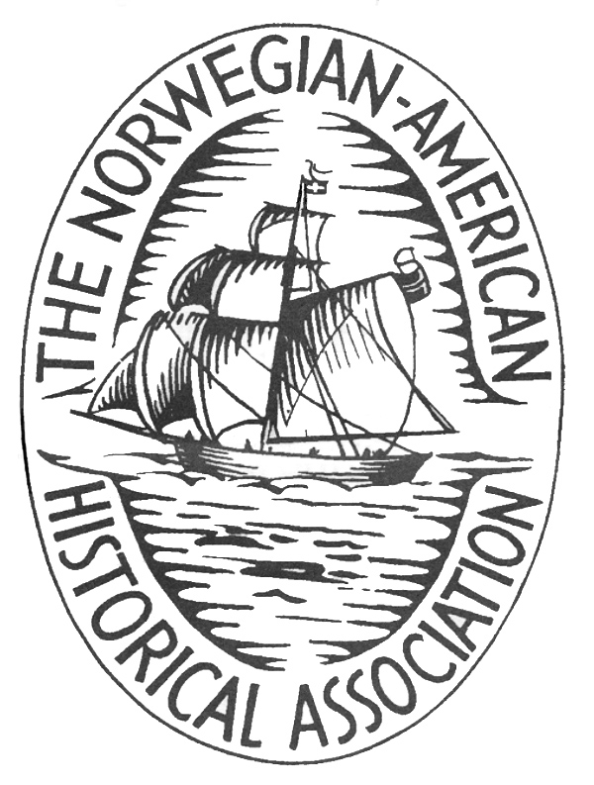

The Norwegian-American Historical Association, Norway
(NAHA-Norge)
DET NORSK-AMERIKANSKE HISTORIELAGET I NORGE
(NAHA-Norge)

Seminar XIV:
Nordic Identity Formation in a Transnational Context
Norsk Utvandrermuseum, Stange ved Hamar
17.-20. juni 2020

The 14th seminar of the Norwegian-American Historical Association in Norway, entitled Nordic Identity Formation in a Transnational Context will be held on June 17-20, 2020, at Norsk Utvandrermuseum, Stange ved Hamar, Norway.
Call for Papers

Nordic Identity Formation in a Transnational Context

The NAHA-Norge seminar in 2020 will explore identity formation among Norwegian immigrants and immigrant groups from other Nordic countries in America from the time of immigration until present. Likewise, as part of globalization immigrants become transnationals, where immigrants have increasing contact with individuals and organizations in their country of origin. Thus, the seminar focuses on the transnational ties between immigrants from the Nordic countries in America and between the immigrants and their country of origin and how this contact affected the identity of Nordic Americans.

In early scholarship of migration and ethnic history, scholars characterized the immigration experience as an inevitable process in which immigrants were molded to become Americans of some sort. However, migration scholars in the past decades have stated that the process of identity formation usually develops in a mutual negotiation between the immigrant and the host society in which both may be altered during the process. We encourage papers on a wide variety of topics relating to the adaptation and identity formation process among different immigrant groups from the Nordic countries in America relating to gender, class, regional, and ethnic or indigenous background. In sum, papers should focus on various narratives in which the ties between immigrants from the Nordic countries in America are taken into account.

NAHA-Norway encourages seminar contributions based on many academic traditions. Topics related to literary, linguistic, and religious studies, to history, social science, fine and folk arts, and cultural studies—as well as multi- and interdisciplinary approaches—are appropriate. NAHA-Norway also emphasizes the need to see Norwegian-American Studies in the context of international migration and ethnic studies in general. Presentations may be delivered in English or Norwegian, and, except for invited lecturers, should not exceed twenty minutes. We require an abstract in English for all presentations, including those held in Norwegian.
Prospective speakers are invited to submit a half-page proposal and a one-page CV to NAHA-Norway Chair Nils Olav Østrem (nils.o.ostrem@uis.no) or Ole Jone Eide (ole.j.eide@uis.no) by January 1, 2020. Further information on the conference will be available on the NAHA-Norway website https://nahanorge.wordpress.com/

