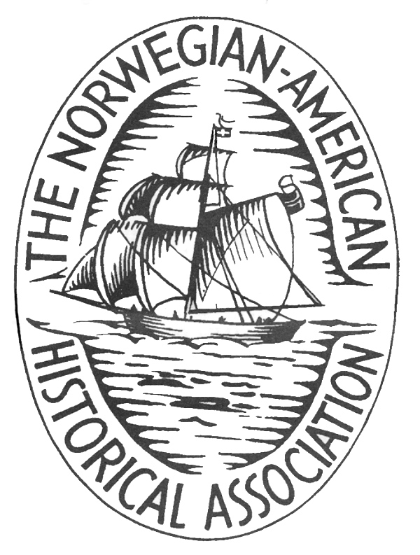

The Norwegian-American Historical Association, Norway Chapter
(NAHA-Norge)

Migration, minorities and freedom of religion

at Stavanger Katedralskole Kongsgård, Stavanger

June 21-24, 2017

Participant Name(s): ___________________________________________________________

Address: _____________________________________________________________________

Email: _________________________________________ Phone: _______________

Hotel chosen:__________________________________________________________________
Please note that you MUST make your own reservations and payment arrangements for accommodations at the hotel of your choice, so the information here is only for our planning purposes. See information sheet for hotel options, contact information and pricing.

Registration Options
Seminar registration fee:
Regular NOK 1400 each x _______ = _____________
Student NOK 1200 each x _______ = _____________

Friday Night Banquet NOK 600 each x _______ = _____________

Total Amount Due NOK _____________

Contact treasurer Ellen Vollebaek should you not be able to participate all three days.

Payment:
For residents in Norway, please pay to NAHA-N's account (DnB): 0531.08.01811
Remember to mark you name clearly!
(US residents may pay to NAHA-Northfield, further information to come on their website)

Please note any dietary restrictions ____________________________________________________

________________________________________________________________________________

Registration and payment should be received by May 16, 2017.
The form should be sent to Ellen Vollebaek, preferably at evollebaek@gmail.com
or to postal address: President Harbitz gt 14, 0259 Oslo.
For questions, you can also call her : 480 76 229

